Jerneja Vidmar, MD, MSc

General and Plastic, Reconstructive and Esthetic Surgeon

Department of Plastic and Reconstructive Surgery, University Medical Centre Maribor, Slovenia

This is a case of a 75-year-old male with an extensive chronic venous ulcer of the right cruris that covered approximately two thirds of his right cruris for 7 years. It was etiologically connected to post-thrombotic syndrome, a consequence of poorly recanalized femoro-popliteal deep venous thrombosis (open fracture and osteosynthesis of the right ankle in 1990), venous insufficiency, secondary AV fistulas and posttraumatic arthrosis of the right ankle. There were no abnormalities of arteries according to US examination. He had disturbed glucose tolerance, arterial hypertension and was overweight.

Secondary AVFs of the right cruris were embolized. Infection of the ulcer was treated by antibiotics according to antibiogram. Ulcer was debrided and advanced wound dressings were applied. He did not tolerate the compression therapy with short-stretch bandages.

He presented with a clean ulcer that covered the whole antero-medial side of the right cruris. There were two smaller defects on the lateral side as well.

Debridement with the hydro surgery system (Versajet) was performed under spinal anesthesia. Swab for microbiology was collected at the time of debridement and treatment with antibiotics according to the antibiogram followed. V.A.C VeraFlo Therapy was initiated after debridement (saline solution, instillation every 5 hours, soaking time 20 minutes, continuous negative pressure at -100 mmHg). Dressing changes were performed after 2 and 3 days. Ulcer was clean and covered by homogenous, abundant granulation tissue after 8 days when the second operation under spinal anesthesia was performed. Gentle removal of the upper layer of granulation tissue by the hydro surgery system (Versajet) was performed and surface was covered by non-meshed split thickness skin transplants. The right cruris was healed 15 days later.

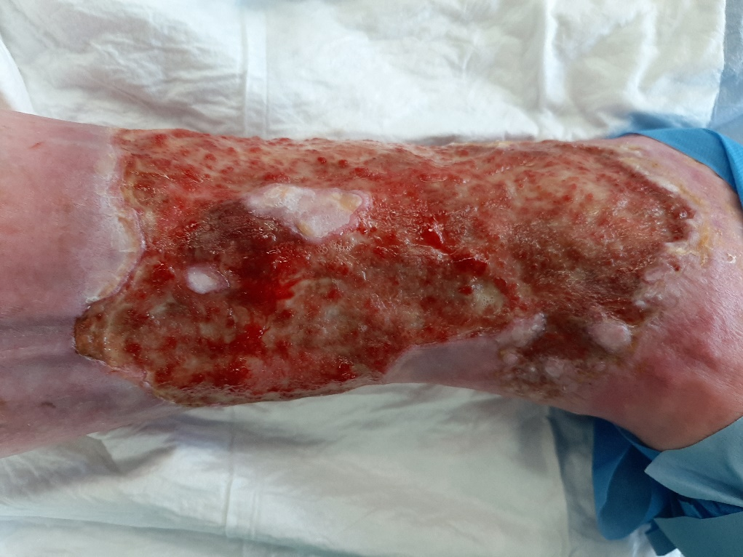

Fig. 1: Ulcer before debridement.

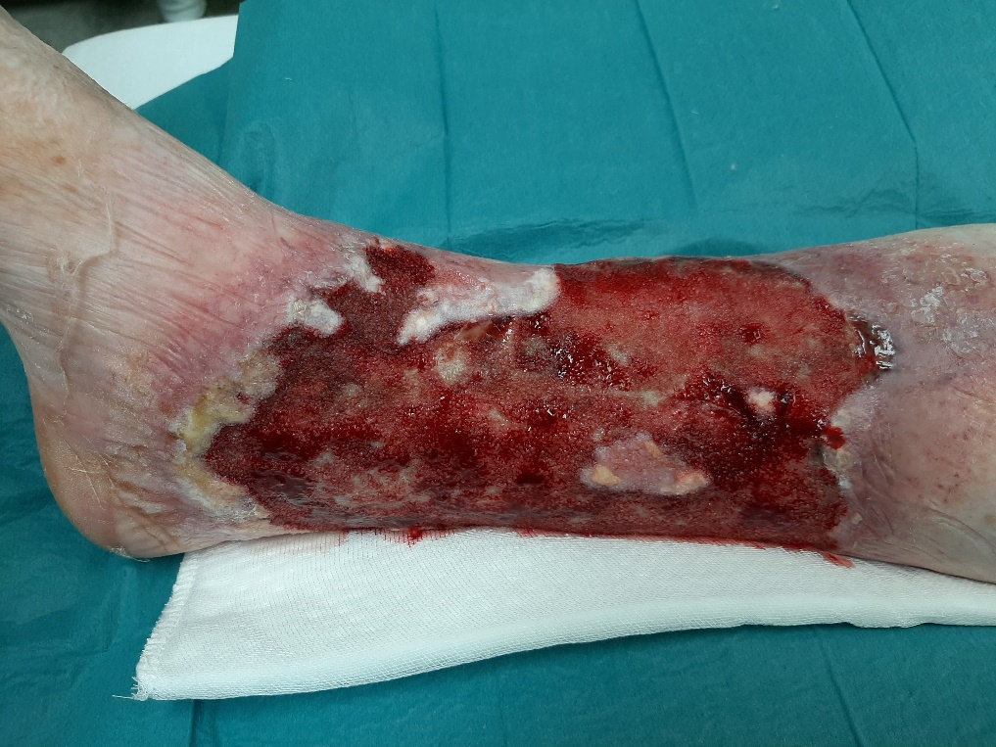

Fig. 2: Granulations after the first change of VAC Veraflo therapy (2 days).

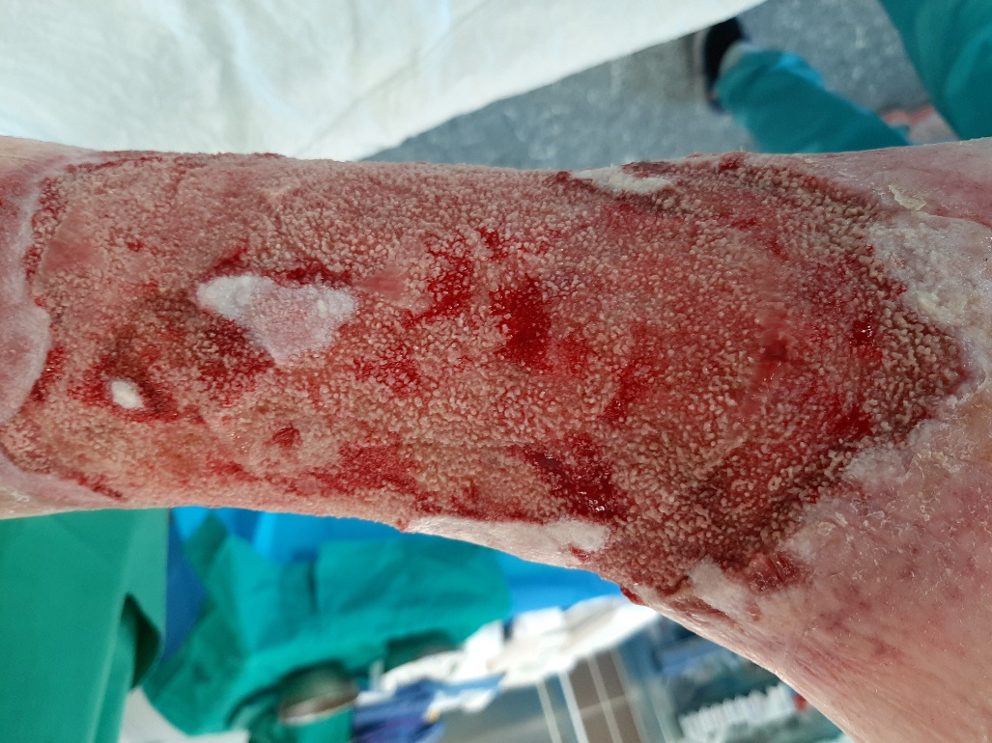

Fig. 3: Abundant granulations after 8 days of VAC Veraflo therapy.

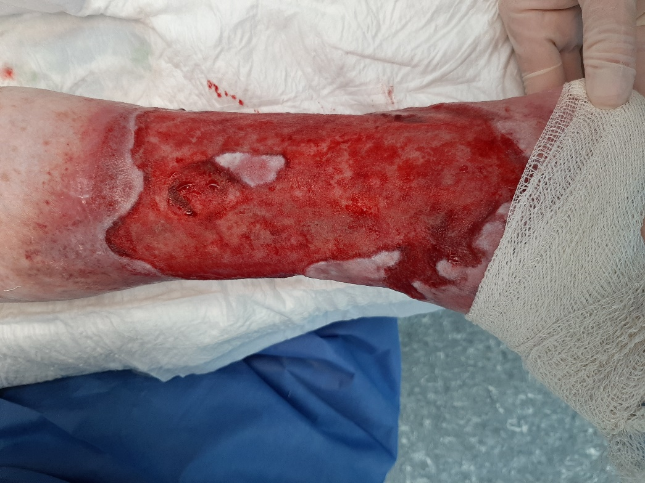

Fig. 4: After hydrosurgical removal of upper layer of granulations.

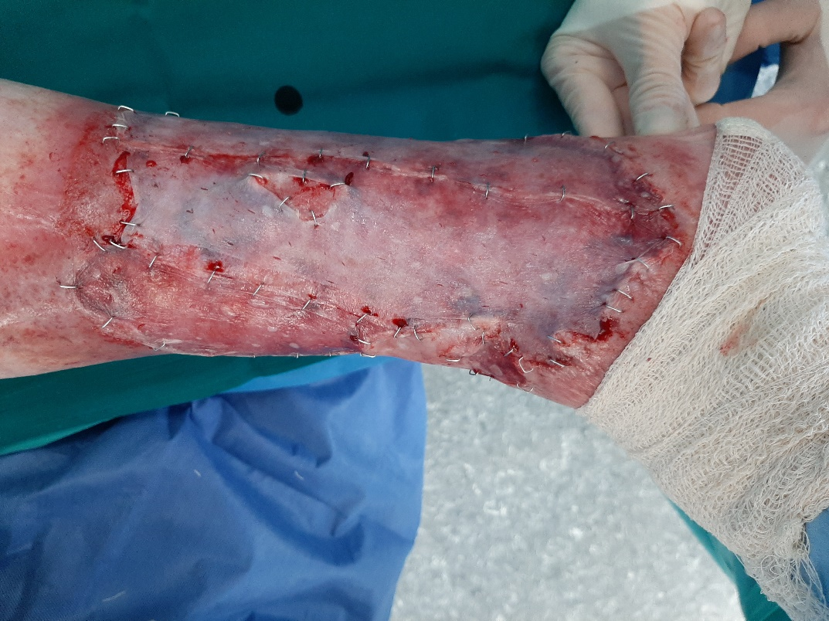

Fig. 5: Split thickness skin transplants.

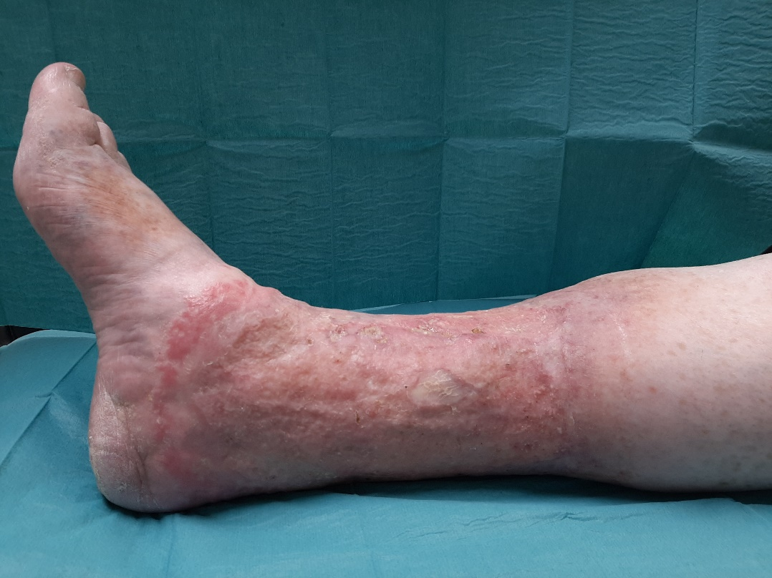

Fig. 6: Healed cruris after 2 months.