**managEment of chronic wounds using v.a.c. veraflo™ therapy**

Author: Miloš Potkonjak dr.med.

General Hospital Novo mesto (Slovenia)

**CASE STUDY**

**chronic wound – *Syndroma Leriche***

***Amputatio femoris bill,***

***DM II, MRSA, Anaemia***

**Introduction:** A 64-years old, male patient was admitted to the Emergency Centre of General Hospital Novo mesto on 23th October 2017 due to the pain in both legs, lasting for three weeks. The patient stated that he could walk up to 30 metres before experiencing severe pain. The pain was also present in both legs while resting. The patient is a diabetic and a long-time heavy smoker. Upon examination, ultrasound showed a fairly good flow and compressible veins with an anechogenic lumen. Few days later, after the Computer Tomography Angiography (CTA) of the pelvic arteries and arteries of the lower extremities, the diagnosis of Leriche syndrome was made, with a relatively high incarceration. The patient also had a problem with superficial femoral arteries.

**Method:** On 22nd February 2018 the patient was admitted to the hospital and laboratory tests showed increased inflammatory parameters. Two-tier antibiotic therapy was prescribed. We performed an upper knee amputation of the right leg (Fig. 1). After the surgical procedure was performede inflammatory parameters raised again. By microbiological examination *Methicilin-Resistant* *Staphyloccocus Aureus* (MRSA) was isolated. After the administration of Vancomycin, the inflammatory parameters decreased. During hospitalization of the patient we regularly changed the postoperative wound dressings (every 2-3 days). On 23rd March 2018 the patient was discharged with proper antibiotic therapy.

On 9th May 2018 the patient returned to the hospital due to the sore wounds on left leg. We performed an upper knee amputation of left leg (Fig. 2) and on 16th May 2018 the patient was discharged with instructions.

On 24th June 2018 the patient was admitted back to the hospital with the onset of chronic wounds at the sites of the amputated legs. On the left leg the gangrene with wound dehiscence was present and on the right leg the necrosis of the skin (Fig. 3). We introduced antibiotic therapy and made control wound swabs for the microbiological examination.

On 27th July 2018 we started with regular V.A.C. Therapy.

On 17th August 2018 we installed V.A.C. Therapy on the chronic wound on the right leg and changed it regularly every 5-7 days until 13th of September 2018. After removing the V.A.C. therapy the wounds were calmed and we changed the dressings every 2-3 days.

On 11th January 2019 the patient came to the hospital due to the worsening of both wounds at the sites of amputation (Fig. 4, 5, 6). Once the necrectomy was done we put the patient on V.A.C VeraFlo therapy. We used Prontosan as the solution of choice. Dwell time was set for 20 min and V.A.C therapy cycle was set for 4 hours. Prior the application we protected periwound with 3M Cavilon. V.A.C Veraflo dressing changes were done five times (every 7 days). After that period the wound was nicely cleaned and soothed.

On 2nd February 2019 we did a reconstruction of the exposed bone on both sides and reinstalled the V.A.C therapy. After less than one month of therapy with V.A.C Veraflo, the wound was cleaned, healthy hypergranulation was present and the wounds showed signs of improvement and healing. Upon completion with V.A.C Veraflo therapy there was no need to perform any debridment of the wound. The patient was discharged from the hospital with granulated and clean wounds. After the discharge of the patient he came to the outpatient department for chronic wounds, checking up every few days.

On 17th May 2019 wounds were completely healed (Fig 8).

**Conclusion:** Chronic, nonhealing wounds pose a continual challenge in medicine due to variable management strategies and inconsistent response to treatment. Treatment is often variable and costly, demanding lengthy hospital stays or specialized home care nursing and costly supplies. With V.A.C. Veraflo we can accelerate the process of chronic wound healing, shorter hospitalization of patients and gain earlier return of function.

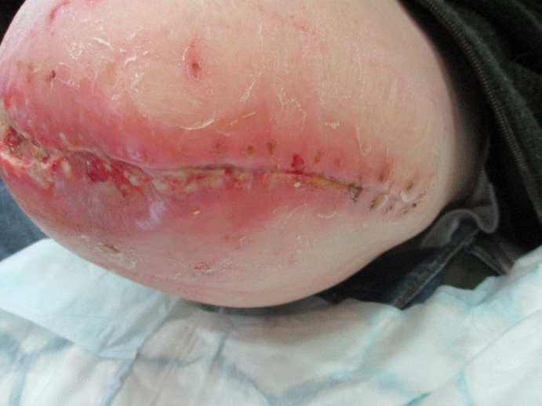 Figure 1: Upper knee amputation of the right leg

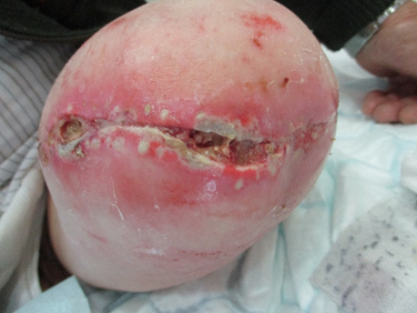 Figure 2: Upper knee amputation of the left leg.

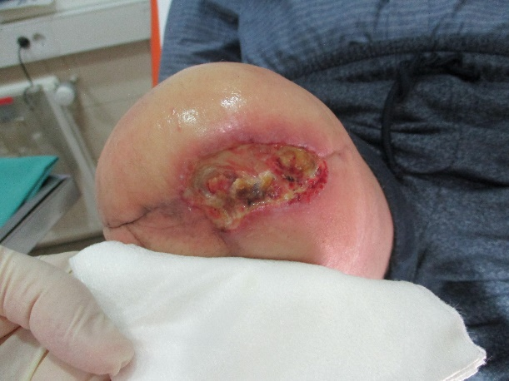 Figure 3: Worsening of the wound after the amputation of the right leg.

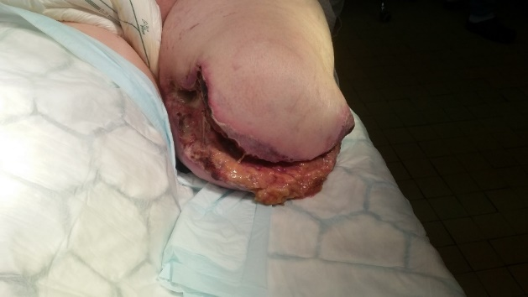 Figure 4- Worsening of the wound after the amputation of the right leg.

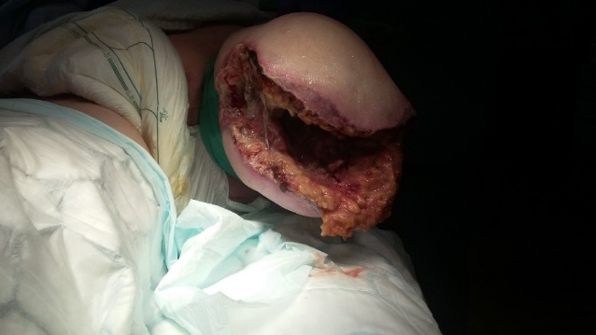 Figure 5- Worsening of the wound after the amputation of the right leg.

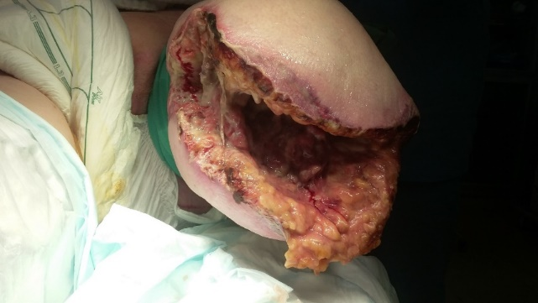 Figure 6 - Worsening of the wound after the amputation of the right leg.

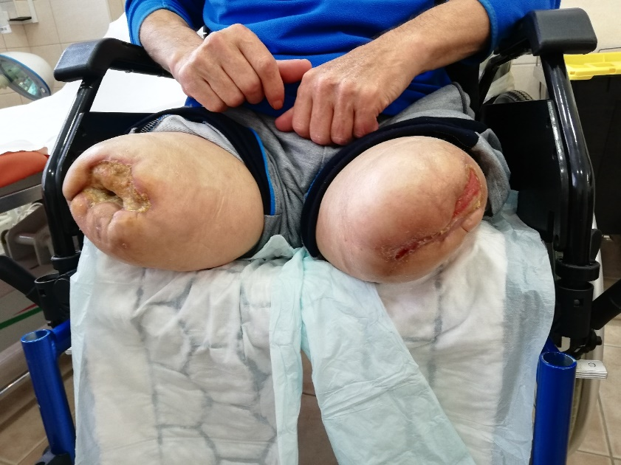 Figure 7 – The wounds after V.A.C. VeraFlo Therapy.

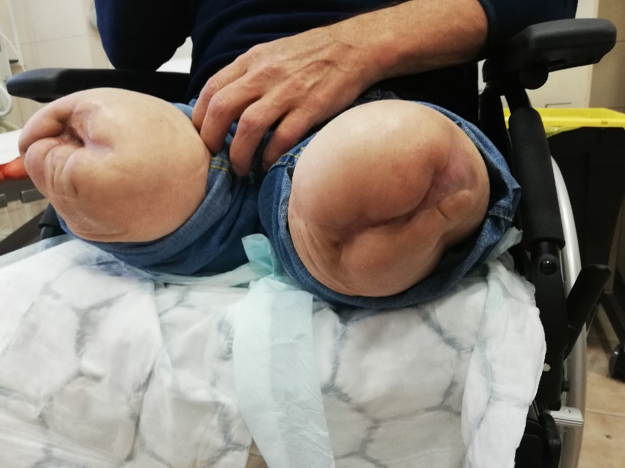 Figure 8 - Completely healed wounds.